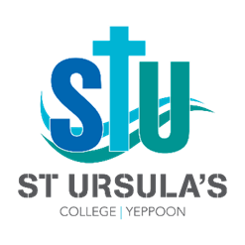
Appointment of Deputy Principal – Learning and Innovation

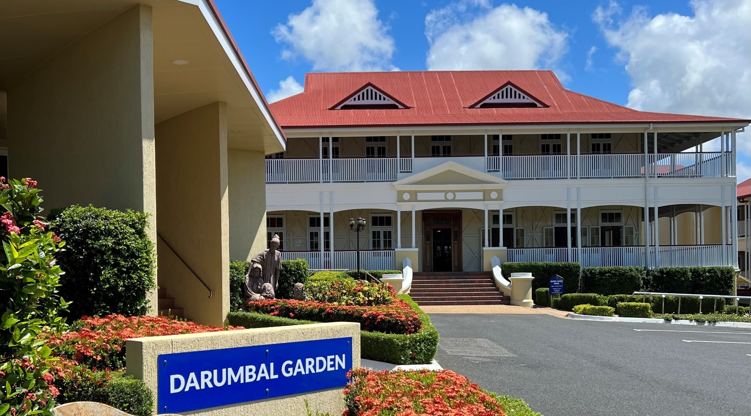
Information for Applicants

Our Organisation
St Ursula’s College, Yeppoon, was founded in 1918 by the Sisters of the Presentation of the Blessed Virgin Mary (PBVM) and is a Ministry of Mercy Partners. As an independent Girls Catholic Day and Boarding Secondary College, St Ursula’s offers an education for young women of the future based on gospel values and Nano Nagle’s vision.
At St Ursula’s College, we offer girls in Years 7-12 a holistic, comprehensive, faith-filled Secondary education encompassing academic and vocational pathways to tertiary study and /or employment. We celebrate every student and their unique abilities; this dynamic culture produces strong, confident young women, capable of forging a positive path for themselves by embracing the College motto of “Perfice Gressus Meos” (Perfect My Steps).
Our vision for educational excellence sees an emphasis on an environment where the gospel values are experienced both in daily living and through authentic and engaging learning experiences, developing critical and future-focussed learners.

Our Vision
St Ursula’s College is a vibrant Faith community providing a holistic Catholic education and residential environment through which young women are encouraged to realise their potential; founded on the charism of Nano Nagle and the values of the Presentation Sister’s; yet responsive to the demands created by the social dynamics of the 21st Century.

Our Mission
We declare that the mission of St Ursula's College is to continue the mission of Jesus, living and proclaiming the Gospel values to all people, especially in our school community, with fidelity, joy and enthusiasm.

Our mission demands that we create an environment where the Gospel values - both in daily living and in the learning situation - can be critically examined, clearly understood and responsibly acted upon.

This demands serious and courageous involvement in the field of education and in the practice of justice in our efforts to transform the world.

Our Values
Respect - We believe in the dignity of each person and encourage all to treat others with consideration and courtesy, acknowledging the value of other viewpoints and life experiences. We strive to ensure that all members of the College community are treated with fairness and equity.
Faith - We seek to make students aware of our rich Catholic heritage, nurturing this as the source of Catholic identity and living. We strive to build upon the faith and commitment of the Presentation Sisters who founded the College by providing Religious Education and experiences of prayer, liturgy and social action that make the faith dimension of this College life-giving and relevant.
Excellence - We believe that each human being is endowed with individual gifts that deserve recognition and development. We strive to promote an environment where all are encouraged and enabled to develop their potential and experience success according to personal capabilities and circumstances.
Compassion - We believe we have a responsibility for the well-being of others in and beyond our community, particularly those who are suffering or vulnerable. We strive to develop a sense of concern for others and a spirit of service so that this concern is expressed and enacted.
Hospitality - We believe that a Christian community is inclusive. We strive to develop a sense of welcome and an acceptance of others such that all in the community are inspired to demonstrate a willingness to share their talents and cultures to enhance life for all. We promote and model reconciliation and strive to restore relationships when conflict or division occur.
Simplicity - We value all of creation and the interconnectedness of life. We strive to develop a sense of appreciation for our physical environment and personal resources. We promote good stewardship and social responsibility rather than a focus on material possessions.

Position Overview
PURPOSE OF POSITION
The Deputy Principal – Learning and Innovation is a member of the College Leadership Team (CLT), with specific roles and responsibilities including the designated deputising authority during periods of the Principal’s absence and provides specific leadership in the areas of teaching and learning, delegated by the Principal. As part of the CLT, the Deputy Principal – Learning and Innovation works collaboratively with all members of the team to play an important role in the visioning and strategic planning in order to position the College as a transformational leader in Catholic girls’ education.
The Deputy Principal – Learning and Innovation will be a passionate and innovative educational leader who will be responsible for the provision of an educational environment that reflects the mission, values and goals of the College and the Strategic Plan.
As the Deputy Principal – Learning and Innovation is a member of the College Leadership Team the incumbent contributes to the following leadership dimensions:
- Strategic Leadership – committed to the strategic priorities of the College that promotes continuous improvement of the College and its staff.

- Spiritual Leadership – to discern, foster and nurture the Catholic ethos of the Presentation Sisters and Mercy Partners Ministries as evidenced through a commitment to a Christian life both in the College context and the local community.

- Educational Leadership – ensures and fosters excellence in learning and teaching programs to nurture quality outcomes.

- Staff and Community Leadership – develop and promote quality respectful and positive relationships that are reflective of our Catholic and Presentation stories.

- Organisational Leadership – facilitates the alignment of College policies, processes and resources, modelling professionalism, effective communication and a commitment to excellence.

RESPONSIBILITIES AND DUTIES
Strategic Leadership
- Lead the development of a College timetable that reflects the vision for teaching and learning at the College
- Curriculum planning for future pathways
- Contribute to the processes of strategic planning
- Lead the identification of opportunities for professional learning
- Assist the Principal in the recruitment of teaching staff, including probationary reviews, LSL or exit interviews
- Creates College wide processes and strategies that are a response to data analysis
- Lead with the College Principal the Annual Improvement Plan specific goals and report progress
- Organisation and support of major College events, i.e. Academic Assemblies, Graduation and Presentation Evening
- Develop and review policies & processes to facilitate effective and efficient Teaching and Learning at the College
- Respond to emerging issues and challenges in education to support the College’s focus on continuous growth

Community Leadership
- Induction of teaching staff and support of boarding staff in best practice study skills and liaison with teaching staff to support boarder success
- Leading the Early Career Teacher Program including supervision of Permission to Teach Teachers
- Support and development of teachers seeking HAT and LEAD accreditation
- Liaise with Initial Teacher Education providers and preservice teachers
- Lead coaching conversations and goal setting for teaching staff
- Participation in new student enrolment interviews
- Development of the 21C Program in conjunction with Deputy Principal – Students
- Lead the Homework Club Program

Religious Leadership
- As a member of the College leadership Team be supportive of the spiritual life of the College
- Demonstrate a commitment to Catholic ethos
- Supports acts of community service and social justice
- Extends emotional support and spiritual care to others
- Provide pastoral care of staff, students & the College community
- Support the Catholic worldview through the learning & teaching at the College

Educational Leadership
- Support the Assistant Principal – Student Outcomes and Curriculum Leaders to enact the learning agenda and determine priorities in alignment with the College Strategic Plan
- Build a common language & shared pedagogical practice in the College’s learning community
- Develop College wide processes and strategies that are a response to data analysis in collaboration with the Assistant Principal – Student Outcomes and the Curriculum Leaders
- Lead with the College Leadership Team and Curriculum leaders to ensure that the College is achieving their annual improvement plan goals in literacy and numeracy
- Promote and maintain an educational environment that is safe, respectful, tolerant, inclusive and promotes individual excellence
- Leads to ensure a continuity of a culture of collaboration and teamwork, empowering staff through professional growth and improvement opportunities
- Lead Student Pathways and development of the Skills and Training Pathways
- Regularly report to the College Board and College Leadership Team on issues and emerging trends in education

Organisational Leadership
- Ensure compliance with all QCAA processes and procedures including confirmation, endorsement and data management
- Develop annual Professional Learning Plans and Programs for staff
- Coordinate and implement staff professional learning opportunities
- Lead in conjunction with the Deputy Principal Students the transition program for new students and Year 11 students into senior school

OTHER KEY ACCOUNTABILITIES

Student Protection

Student Protection is everyone’s responsibility. At St Ursula’s College all person’s undertaking work for or on behalf of the College, have a shared responsibility for contributing to a child safe environment. All person’s are to be familiar with the content of the College’s Student Protection documents, including but not limited to Polices, Procedures, Codes of Conduct and Processes and their legal obligation to the reporting of child abuse. It is each individual’s responsibility to be aware of key risk indicators of child abuse, to be vigilant and observant, and to raise any concerns they may have to the Student Protection Officers at the College. All individual’s are required to participate fully in and understand the content of the training provided.

Shared Responsibilities

- Be supportive of the goals, ethos and Mission of the College as a Catholic College in the Presentation tradition.
- Display high levels of professionalism ensuring that behaviours reflect the College Values and expectations.
- Take full responsibility for compliance with the Staff Code of Conduct.
- Have an awareness of and support for the policies, procedures and practices of the College.
- Take full responsibility for compliance with all school policies and procedures.
- Given the dynamic environment in which the College operates the Principal may alter the responsibilities of this position at her discretion, in order to most effectively serve the needs of the College.

Deputy Principal Essential Eligibility Criteria

- A clear vision and support of Catholic education, St Ursula’s College mission, values and ethos of the Presentation charism.
- Queensland College of Teachers Registration
- Excellent interpersonal, oral and written communication skills and a proven ability to professionally relate to and role model to other staff members.

Deputy Principal Desirable Eligibility Criteria

- Experience at a leadership level in a secondary school
- Postgraduate qualifications in Education, Theology or Religious Education, or willingness to engage in further studies
- Previous experience in a similar role.

Deputy Principal – Learning and Innovation Selection Criteria
- Demonstrated ability to foster and grow the religious life of the College, and provide leadership through personal example.
- Demonstrated ability in the development, implementation, and monitoring of high-quality learning and teaching programs, including pedagogical change.
- Demonstrated ability in the selection, deployment, support and development of staff through regular coaching, goalsetting and reviews, professional learning and enactment of positive and respectful relationships.
- Demonstrated ability to collaboratively assist in the formation and implementation of strategies to support strategic directions and alignment.

The Application Process

We are seeking an energetic, passionate and knowledgeable educational leader, with a commitment to all girls Catholic education, and the College’s vision of personal excellence in education.

We welcome applications from suitably qualified and experienced professionals for the position of Deputy Principal – Learning and Innovation, commencing Term 1, 2024.

Application should be submitted to the Principal, Deborah Ryan, no later than 4 pm Friday 14 July via recruitment@stursulas.qld.edu.au and should include the following:

- A covering letter
- Curriculum Vitae
- A written statement of no more than 1000 words addressing the selection criteria
- The contact details of three (3) professional referees, one of whom should be your current employer.

Receipt of your application will be acknowledged by email.

